ELEG 309 - Example Problems Chapter 1-2

**Example 1.3**

Figure 1.17 depicts an amplifier composed of a cascade of three stages. The amplifier is fed by a signal source with a source resistance of 100 k and delivers its output into a load resistance of 100 . The first stage has a relatively high input resistance and a modest gain factor of 10. The second stage has a higher gain factor but lower input resistance. Finally, the last, or output, stage has unity gain but a low output resistance. We wish to evaluate the overall voltage gain, that is, *vL*/*vs*, the current gain, and the power gain.

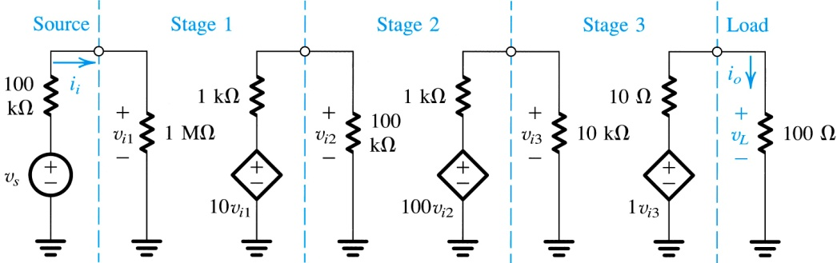

**Figure 1.17** Three-stage amplifier for Example 1.3.

**Example 1.4**

The bipolar junction transistor (BJT), which will be studied in Chapter 6, is a three-terminal device that when powered-up by a dc source (battery) and operated with small signals can be modeled by the linear circuit shown in Fig. 1.19(a). The three terminals are the base (B), the emitter (E), and the collector (C). The heart of the model is a transconductance amplifier represented by an input resistance between B and E (denoted *rπ*), a short-circuit transconductance *gm*, and an output resistance *ro*.

With the emitter used as a common terminal between input and output, Fig. 1.19(b) shows a transistor amplifier known as a common-emitter or grounded-emitter circuit. Derive an expression for the voltage gain *vo*/*vs*, and evaluate its magnitude for the case *Rs* = 5 kΩ, *rπ* = 2.5 kΩ, *gm* = 40 mA/V, *ro* = 100 kΩ, and *RL* = 5 kΩ. What would the gain value be if the effect of *ro* were neglected?

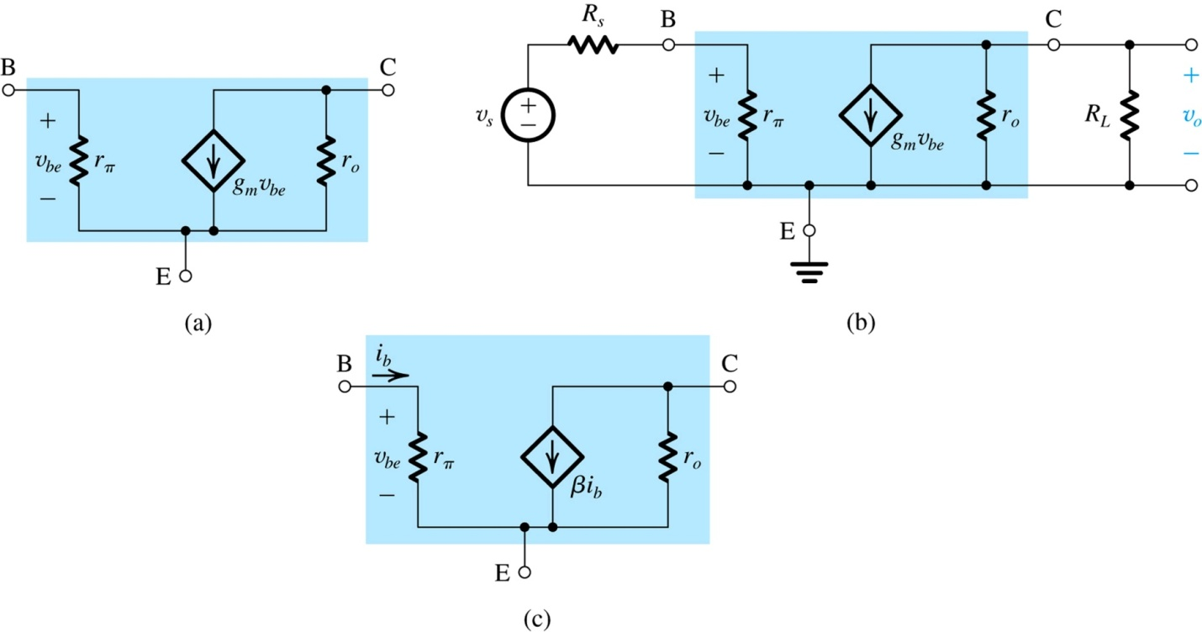

**Figure 1.19 (a)** Small-signal circuit model for a bipolar junction transistor (BJT). **(b)** The BJT connected as an amplifier with the emitter as a common terminal between input and output (called a common-emitter amplifier). **(c)** An alternative small-signal circuit model for the BJT.